Codebook for DDS Analytics

Talent Management Solutions for DDS Analytics

2018-11-23 18:44:41

# Data report overview

The dataset examined has the following dimensions:

|  |  |
| --- | --- |
| Feature | Result |
| Number of observations | 1470 |
| Number of variables | 31 |

# Codebook summary table

|  |  |  |  |  |  |
| --- | --- | --- | --- | --- | --- |
| Label | Variable | Class | # unique values | Missing | Description |
|  | **Age** | integer | 43 | 0.00 % | Age |
|  | **Attrition** | factor | 2 | 0.00 % | Attrition |
|  | **BusTravel** | factor | 3 | 0.00 % | Business Travel |
|  | **DailyRate** | integer | 886 | 0.00 % | Daily Rate |
|  | **Department** | factor | 3 | 0.00 % | Department |
|  | **DistFromHome** | integer | 29 | 0.00 % | Distance from Home |
|  | **Education** | integer | 5 | 0.00 % | Education |
|  | **EducationFd** | factor | 6 | 0.00 % | Education Field |
|  | **[EmployeeCount]** | integer | 4 | 0.00 % | Environment Count |
|  | **[EmployeeNumber]** | integer | 4 | 0.00 % | Environment Number |
|  | **EnvSatis** | integer | 4 | 0.00 % | Environment Satisfaction |
|  | **Gender** | factor | 2 | 0.00 % | Gender |
|  | **HourlyRate** | integer | 71 | 0.00 % | Hourly Rate |
|  | **JobInvolvemt** | integer | 4 | 0.00 % | Job Involvement |
|  | **JobLevel** | integer | 5 | 0.00 % | Job Level |
|  | **JobRole** | factor | 9 | 0.00 % | Job Role |
|  | **JobbSatis** | integer | 4 | 0.00 % | Job Satisfaction |
|  | **MaritalStat** | factor | 3 | 0.00 % | Marital Status |
|  | **MntlyIncome** | integer | 1349 | 0.00 % | Monthly Income |
|  | **MntlyRate** | integer | 1427 | 0.00 % | Monthly Rate |
|  | **NumCompWrk** | integer | 10 | 0.00 % | Number of Companies worked |
|  | **OverTime** | factor | 2 | 0.00 % | Overtime |
|  | **PercSalHike** | integer | 15 | 0.00 % | Percentage Salary Hike |
|  | **PerfRating** | integer | 2 | 0.00 % | Performance Rating |
|  | **RelatSatis** | integer | 4 | 0.00 % | Relationship Status |
|  | **StkOptLevel** | integer | 4 | 0.00 % | Stock Options Level |
|  | **TotalWrkYrs** | integer | 40 | 0.00 % | Total Working Years |
|  | **TrTmLastYr** | integer | 7 | 0.00 % | Training Times Last Year |
|  | **WrkLfBalance** | integer | 4 | 0.00 % | Work Life Balance |
|  | **YrsAtComp** | integer | 37 | 0.00 % | Years at the company |
|  | **YrsInCurrRle** | integer | 19 | 0.00 % | Years in current role |
|  | **YrsSceLstProm** | integer | 16 | 0.00 % | Years since last promotion |
|  | **YrsWtCurrMgr** | integer | 18 | 0.00 % | Years with Current Manager |

# Variable list

## Age

|  |  |
| --- | --- |
| Feature | Result |
| Variable type | integer |
| Number of missing obs. | 0 (0 %) |
| Number of unique values | 43 |
| Median | 36 |
| 1st and 3rd quartiles | 30; 43 |
| Min. and max. | 18; 60 |

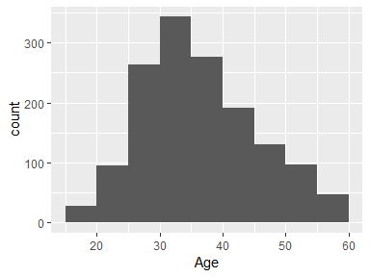

## Attrition

|  |  |
| --- | --- |
| Feature | Result |
| Variable type | factor |
| Number of missing obs. | 0 (0 %) |
| Number of unique values | 2 |
| Mode | “No” |
| Reference category | No |

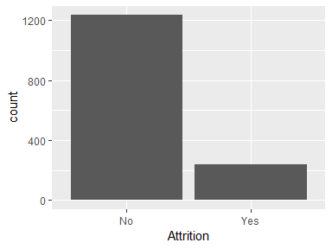

* Observed factor levels: "No", "Yes".

## BusTravel

|  |  |
| --- | --- |
| Feature | Result |
| Variable type | factor |
| Number of missing obs. | 0 (0 %) |
| Number of unique values | 3 |
| Mode | “Travel_Rarely” |
| Reference category | Non-Travel |

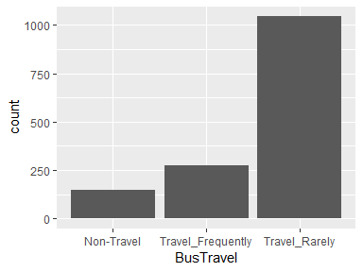

* Observed factor levels: "Non-Travel", "Travel_Frequently", "Travel_Rarely".

## DailyRate

|  |  |
| --- | --- |
| Feature | Result |
| Variable type | integer |
| Number of missing obs. | 0 (0 %) |
| Number of unique values | 886 |
| Median | 802 |
| 1st and 3rd quartiles | 465; 1157 |
| Min. and max. | 102; 1499 |

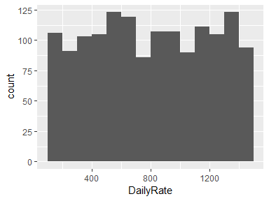

## Department

|  |  |
| --- | --- |
| Feature | Result |
| Variable type | factor |
| Number of missing obs. | 0 (0 %) |
| Number of unique values | 3 |
| Mode | “Research & Development” |
| Reference category | Human Resources |

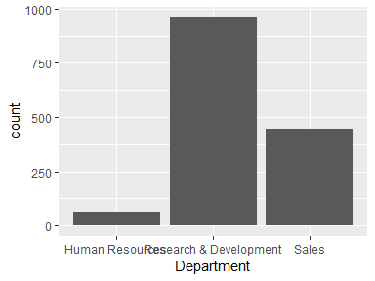

* Observed factor levels: "Human Resources", "Research & Development", "Sales".

## DistFromHome

|  |  |
| --- | --- |
| Feature | Result |
| Variable type | integer |
| Number of missing obs. | 0 (0 %) |
| Number of unique values | 29 |
| Median | 7 |
| 1st and 3rd quartiles | 2; 14 |
| Min. and max. | 1; 29 |

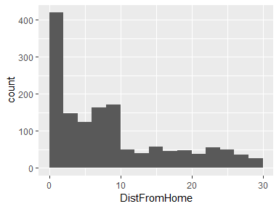

## Education

|  |  |
| --- | --- |
| Feature | Result |
| Variable type | integer |
| Number of missing obs. | 0 (0 %) |
| Number of unique values | 5 |
| Median | 3 |
| 1st and 3rd quartiles | 2; 4 |
| Min. and max. | 1; 5 |

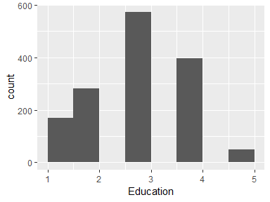

## EducationFd

|  |  |
| --- | --- |
| Feature | Result |
| Variable type | factor |
| Number of missing obs. | 0 (0 %) |
| Number of unique values | 6 |
| Mode | “Life Sciences” |
| Reference category | Human Resources |

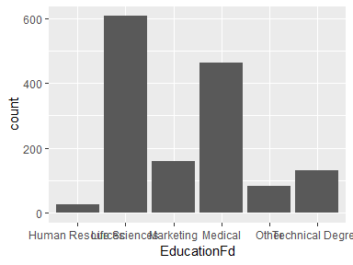

* Observed factor levels: "Human Resources", "Life Sciences", "Marketing", "Medical", "Other", "Technical Degree".

## EnvSatis

|  |  |
| --- | --- |
| Feature | Result |
| Variable type | integer |
| Number of missing obs. | 0 (0 %) |
| Number of unique values | 4 |
| Median | 3 |
| 1st and 3rd quartiles | 2; 4 |
| Min. and max. | 1; 4 |

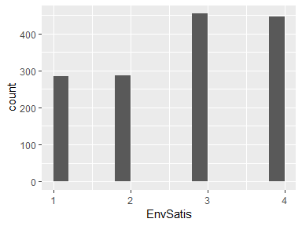

## Gender

|  |  |
| --- | --- |
| Feature | Result |
| Variable type | factor |
| Number of missing obs. | 0 (0 %) |
| Number of unique values | 2 |
| Mode | “Male” |
| Reference category | Female |

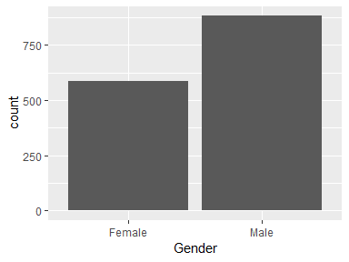

* Observed factor levels: "Female", "Male".

## HourlyRate

|  |  |
| --- | --- |
| Feature | Result |
| Variable type | integer |
| Number of missing obs. | 0 (0 %) |
| Number of unique values | 71 |
| Median | 66 |
| 1st and 3rd quartiles | 48; 83.75 |
| Min. and max. | 30; 100 |

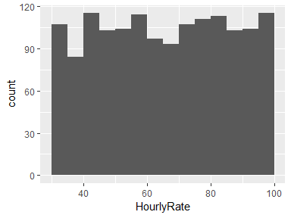

## JobInvolvemt

|  |  |
| --- | --- |
| Feature | Result |
| Variable type | integer |
| Number of missing obs. | 0 (0 %) |
| Number of unique values | 4 |
| Median | 3 |
| 1st and 3rd quartiles | 2; 3 |
| Min. and max. | 1; 4 |

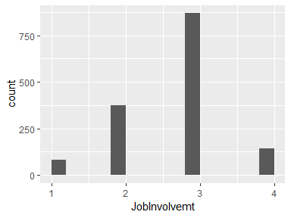

## JobLevel

|  |  |
| --- | --- |
| Feature | Result |
| Variable type | integer |
| Number of missing obs. | 0 (0 %) |
| Number of unique values | 5 |
| Median | 2 |
| 1st and 3rd quartiles | 1; 3 |
| Min. and max. | 1; 5 |

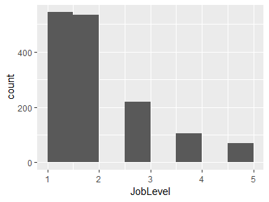

## JobRole

|  |  |
| --- | --- |
| Feature | Result |
| Variable type | factor |
| Number of missing obs. | 0 (0 %) |
| Number of unique values | 9 |
| Mode | “Sales Executive” |
| Reference category | Healthcare Representative |

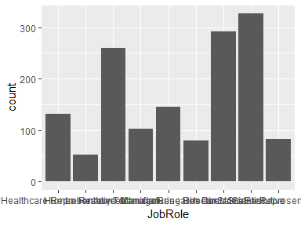

* Observed factor levels: "Healthcare Representative", "Human Resources", "Laboratory Technician", "Manager", "Manufacturing Director", "Research Director", "Research Scientist", "Sales Executive", "Sales Representative".

## JobbSatis

|  |  |
| --- | --- |
| Feature | Result |
| Variable type | integer |
| Number of missing obs. | 0 (0 %) |
| Number of unique values | 4 |
| Median | 3 |
| 1st and 3rd quartiles | 2; 4 |
| Min. and max. | 1; 4 |

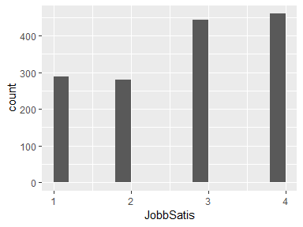

## MaritalStat

|  |  |
| --- | --- |
| Feature | Result |
| Variable type | factor |
| Number of missing obs. | 0 (0 %) |
| Number of unique values | 3 |
| Mode | “Married” |
| Reference category | Divorced |

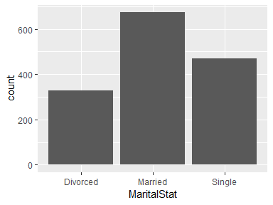

* Observed factor levels: "Divorced", "Married", "Single".

## MntlyIncome

|  |  |
| --- | --- |
| Feature | Result |
| Variable type | integer |
| Number of missing obs. | 0 (0 %) |
| Number of unique values | 1349 |
| Median | 4919 |
| 1st and 3rd quartiles | 2911; 8379 |
| Min. and max. | 1009; 19999 |

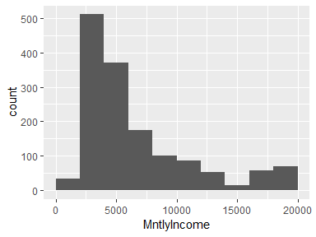

## MntlyRate

|  |  |
| --- | --- |
| Feature | Result |
| Variable type | integer |
| Number of missing obs. | 0 (0 %) |
| Number of unique values | 1427 |
| Median | 14235.5 |
| 1st and 3rd quartiles | 8047; 20461.5 |
| Min. and max. | 2094; 26999 |

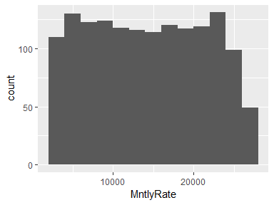

## NumCompWrk

|  |  |
| --- | --- |
| Feature | Result |
| Variable type | integer |
| Number of missing obs. | 0 (0 %) |
| Number of unique values | 10 |
| Median | 2 |
| 1st and 3rd quartiles | 1; 4 |
| Min. and max. | 0; 9 |

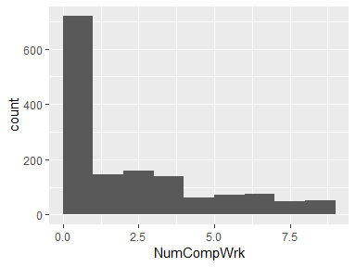

## OverTime

|  |  |
| --- | --- |
| Feature | Result |
| Variable type | factor |
| Number of missing obs. | 0 (0 %) |
| Number of unique values | 2 |
| Mode | “No” |
| Reference category | No |

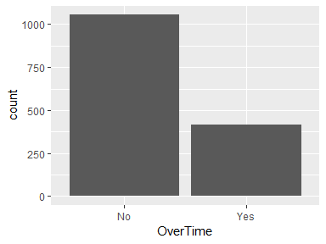

* Observed factor levels: "No", "Yes".

## PercSalHike

|  |  |
| --- | --- |
| Feature | Result |
| Variable type | integer |
| Number of missing obs. | 0 (0 %) |
| Number of unique values | 15 |
| Median | 14 |
| 1st and 3rd quartiles | 12; 18 |
| Min. and max. | 11; 25 |

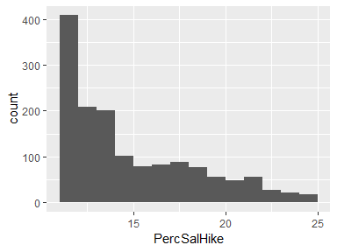

## PerfRating

|  |  |
| --- | --- |
| Feature | Result |
| Variable type | integer |
| Number of missing obs. | 0 (0 %) |
| Number of unique values | 2 |
| Median | 3 |
| 1st and 3rd quartiles | 3; 3 |
| Min. and max. | 3; 4 |

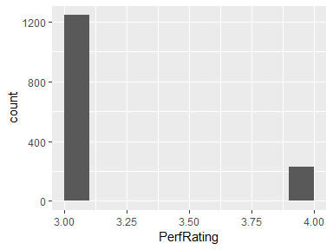

## RelatSatis

|  |  |
| --- | --- |
| Feature | Result |
| Variable type | integer |
| Number of missing obs. | 0 (0 %) |
| Number of unique values | 4 |
| Median | 3 |
| 1st and 3rd quartiles | 2; 4 |
| Min. and max. | 1; 4 |

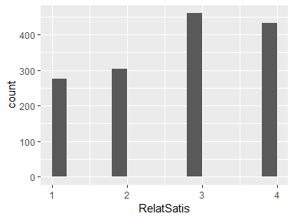

## StkOptLevel

|  |  |
| --- | --- |
| Feature | Result |
| Variable type | integer |
| Number of missing obs. | 0 (0 %) |
| Number of unique values | 4 |
| Median | 1 |
| 1st and 3rd quartiles | 0; 1 |
| Min. and max. | 0; 3 |

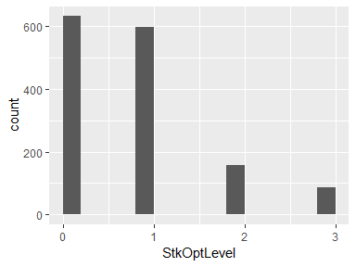

## TotalWrkYrs

|  |  |
| --- | --- |
| Feature | Result |
| Variable type | integer |
| Number of missing obs. | 0 (0 %) |
| Number of unique values | 40 |
| Median | 10 |
| 1st and 3rd quartiles | 6; 15 |
| Min. and max. | 0; 40 |

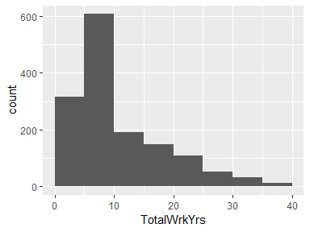

## TrTmLastYr

|  |  |
| --- | --- |
| Feature | Result |
| Variable type | integer |
| Number of missing obs. | 0 (0 %) |
| Number of unique values | 7 |
| Median | 3 |
| 1st and 3rd quartiles | 2; 3 |
| Min. and max. | 0; 6 |

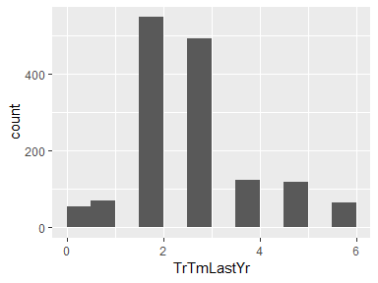

## WrkLfBalance

|  |  |
| --- | --- |
| Feature | Result |
| Variable type | integer |
| Number of missing obs. | 0 (0 %) |
| Number of unique values | 4 |
| Median | 3 |
| 1st and 3rd quartiles | 2; 3 |
| Min. and max. | 1; 4 |

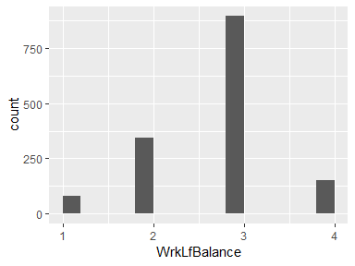

## YrsAtComp

|  |  |
| --- | --- |
| Feature | Result |
| Variable type | integer |
| Number of missing obs. | 0 (0 %) |
| Number of unique values | 37 |
| Median | 5 |
| 1st and 3rd quartiles | 3; 9 |
| Min. and max. | 0; 40 |

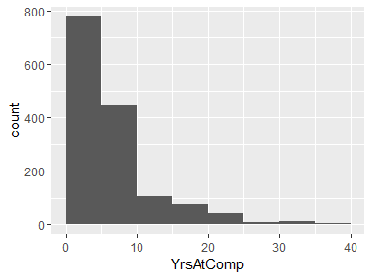

## YrsInCurrRle

|  |  |
| --- | --- |
| Feature | Result |
| Variable type | integer |
| Number of missing obs. | 0 (0 %) |
| Number of unique values | 19 |
| Median | 3 |
| 1st and 3rd quartiles | 2; 7 |
| Min. and max. | 0; 18 |

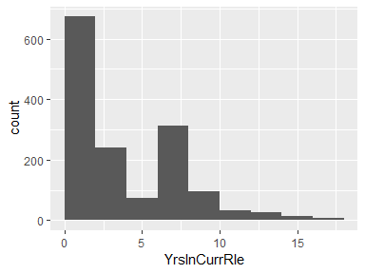

## YrsSceLstProm

|  |  |
| --- | --- |
| Feature | Result |
| Variable type | integer |
| Number of missing obs. | 0 (0 %) |
| Number of unique values | 16 |
| Median | 1 |
| 1st and 3rd quartiles | 0; 3 |
| Min. and max. | 0; 15 |

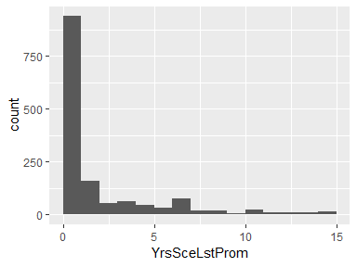

## YrsWtCurrMgr

|  |  |
| --- | --- |
| Feature | Result |
| Variable type | integer |
| Number of missing obs. | 0 (0 %) |
| Number of unique values | 18 |
| Median | 3 |
| 1st and 3rd quartiles | 2; 7 |
| Min. and max. | 0; 17 |

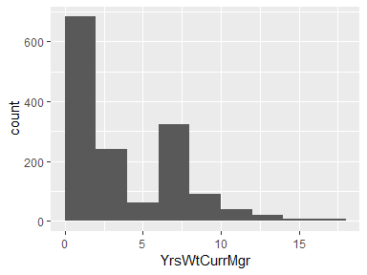

Report generation information:

* Created by error: invalid key: Mylapore/.gitconfig (username: Satish Mylapore).
* Report creation time: Fri Nov 23 2018 18:44:44
* Report was run from directory: C:/Users/Satish Mylapore/Documents/CaseStudy/CaseStudy2/MSDS6306_Case_Study_2/Assignment/Code/Data
* dataMaid v1.2.0 [Pkg: 2018-10-03 from CRAN (R 3.5.1)]
* R version 3.5.1 (2018-07-02).
* Platform: x86_64-w64-mingw32/x64 (64-bit)(Windows >= 8 x64 (build 9200)).
* Function call: makeDataReport(data = data, mode = c("summarize", "visualize", "check"), smartNum = FALSE, file = "codebook_dataCodebook.RMD.Rmd", vol = "Codebook.RMD", checks = list(character = "showAllFactorLevels", factor = "showAllFactorLevels", labelled = "showAllFactorLevels", haven_labelled = "showAllFactorLevels", numeric = NULL, integer = NULL, logical = NULL, Date = NULL), listChecks = FALSE, maxProbVals = Inf, codebook = TRUE, reportTitle = "Codebook for data")